Projet Galer’IT
Camarade 1, Andres Vallejos, Camarade 2
La société Galer’IT a actuellement 4 sites avec des vlans sur chacun d’entre eux :

Réseau Galer’IT :
Adresse de réseau | 192.168.0.0 | 1100 0000. 1010 1000.0000 0000.0000 0000
Masque | 255.255.0.0 | 1111 1111.1111 1111.0000 0000.0000 0000
Première adresse | 192.168.0.1 | 1100 0000. 1010 1000.0000 0000.0000 0001
Dernière adresse | 192.168.255.254 | 1100 0000. 1010 1000.1111 1111.1111 1110
Adresse de broadcast | 192.168.255.255 | 1100 0000. 1010 1000.1111 1111.1111 1111
Nombre d'adresses IP disponibles | 65534

Paris :
VLAN 7 : Admin /24
Vlan 10 : AD (serveur) /24
Vlan 101 : Imprimante /28
Vlan 200 : Personnes 62 /26
Vlan 201 : Personnes 62 /26
Vlan 202 : Personnes 62 /26 192.168.202.0 192.168.202.0
Vlan 203 : Personnes 62 /26 192.168.203.0 192.168.202.64
Vlan 204: Personnes 62 /26 192.168.204.0 192.168.202.128
Vlan 205: Personnes 62 /26
Vlan 30 : Switch /24
Vlan 230 : Router /24

Londres :
VLAN 9 : Admin /24
Vlan 11: AD /24
Vlan 103 : Imprimante /28
Vlan 152 : serveur (backup) /25
Vlan 208 : Personnes 62 /26
Vlan 209 : Personnes 62 /26
Vlan 210 : Personnes 62 /26
Vlan 31 : Switch /24
Vlan 231 : Router /24
Tokyo :
VLAN 6 : Admin /24
Vlan 104 : Imprimante /28
Vlan 153 : serveur (backup) /24
Vlan 211 : Personnes 25 /26
Vlan 32 : Switch /24
Vlan 232 : Router /24
Toulouse :
VLAN 8 : Admin /24
Vlan 102 : Imprimante /28
Vlan 151 : serveur (backup) /28
Vlan 206 : Personnes 62 /26
Vlan 207 : Personnes 62 /26
Vlan 33 : Switch /24
Vlan 233 : Router /24

Site de Paris
Configuration des Switchs du site Paris :

Switch_Paris_1 (Cœur) | Switch_Paris_2
vtp domain Paris  vtp mode server  vtp password cisco  vlan 30  name ssh_paris  exit  vlan 101  vlan 200  vlan 201  vlan 202  vlan 203  vlan 204  vlan 205  vlan 7  vlan 10  interface vlan 30  ip address 192.168.30.1 255.255.255.0  no shutdown  interface range FastEthernet0/23 - 24  switchport mode trunk  switchport nonegotiate  channel-group 1 mode on  no shutdown  exit  interface range FastEthernet0/21 - 22  switchport mode trunk  switchport nonegotiate  channel-group 2 mode on  no shutdown  exit  interface GigabitEthernet 0/1  switchport mode trunk  switchport nonegotiate  end  wr  exit | vtp domain Paris  vtp mode client  vtp password cisco  interface vlan 30  ip address 192.168.30.2 255.255.255.0  no shutdown  interface range FastEthernet 0/1 -7  switchport mode trunk  switchport nonegotiate  exit  interface range FastEthernet0/21 - 22  switchport mode trunk  channel-group 2 mode on  no shutdown  end  wr  exit
 | Switch_Paris_3
vtp domain Paris
vtp mode client
vtp password cisco
interface vlan 30
ip address 192.168.30.3 255.255.255.0
no shutdown
interface range FastEthernet 0/1-2
switchport mode trunk
switchport nonegotiate
exit
interface range FastEthernet0/23 - 24
switchport mode trunk
channel-group 1 mode on
no shutdown
end
wr
exit

Switch Client
vtp domain Paris
vtp mode client
vtp password cisco
interface FastEthernet 0/1
- switchport mode trunk
- switchport nonegotiate
Switch_Paris_4 | Switch_Paris_5
interface vlan 30  ip address 192.168.30.4 255.255.255.0  no shutdown  interface FastEthernet 0/2  - switchport mode access  - switchport access vlan 7 | interface vlan 30  ip address 192.168.30.5 255.255.255.0  no shutdown  interface FastEthernet 0/2  - switchport mode access  - switchport access vlan 10
Switch_Paris_6 | Switch_Paris_7
interface vlan 30  ip address 192.168.30.6 255.255.255.0  no shutdown  interface FastEthernet 0/2  - switchport mode access  - switchport access vlan 200 | interface vlan 30  ip address 192.168.30.7 255.255.255.0  no shutdown  interface FastEthernet 0/2  - switchport mode access  - switchport access vlan 201
Switch_Paris_8 | Switch_Paris_9
interface vlan 30  ip address 192.168.30.8 255.255.255.0  no shutdown  interface FastEthernet 0/2  - switchport mode access  - switchport access vlan 202 | interface vlan 30  ip address 192.168.30.9 255.255.255.0  no shutdown  interface FastEthernet 0/2  - switchport mode access  - switchport access vlan 203
Switch_Paris_10 | Switch_Paris_11
interface vlan 30  ip address 192.168.30.10 255.255.255.0  no shutdown  interface FastEthernet 0/2  - switchport mode access  - switchport access vlan 204 | interface vlan 30  ip address 192.168.30.11 255.255.255.0  no shutdown  interface FastEthernet 0/2  - switchport mode access  - switchport access vlan 205
Switch_Paris_12 | Switch_Paris_6
interface vlan 30
ip address 192.168.30.12 255.255.255.0
no shutdown
interface FastEthernet 0/2
- switchport mode access
- switchport access vlan 101

Configuration SSH sur chaque Switch du site Paris
ip domain-name Galer.com
enable password cisco
username cisco password cisco
line console 0
password cisco
login local
exit
crypto key generate rsa general-keys modulus 1024
ip ssh version 2
ip ssh authentication-retries 5
ip ssh time-out 60
line vty 5 15
login local
transport input ssh
exit
line vty 0 4
login local
transport input ssh
exit
service password-encryption
interface vlan 30
ip default-gateway 192.168.30.254
end
wr
exit

Configuration du router sur le de site Paris :
Configuration router Paris R1
interface gigabitethernet 0/1.200  encapsulation dot1Q 200  ip address 192.168.200.62 255.255.255.192  no shutdown  exit  interface gigabitethernet 0/1.201  encapsulation dot1Q 201  ip address 192.168.201.62 255.255.255.192  no shutdown  exit  interface gigabitethernet 0/1.202  encapsulation dot1Q 202  ip address 192.168.202.62 255.255.255.192  no shutdown  exit  interface gigabitethernet 0/1.203  encapsulation dot1Q 203  ip address 192.168.203.62 255.255.255.192  no shutdown  exit  interface gigabitethernet 0/1.204  encapsulation dot1Q 204  ip address 192.168.204.62 255.255.255.192  no shutdown  exit  interface gigabitethernet 0/1.205  encapsulation dot1Q 205  ip address 192.168.205.62 255.255.255.192  no shutdown  exit  interface gigabitethernet 0/1.101  encapsulation dot1Q 101  ip address 192.168.101.14 255.255.255.240  no shutdown  exit  interface gigabitethernet 0/1.7  encapsulation dot1Q 7  ip address 192.168.7.254 255.255.255.0  no shutdown  exit  interface gigabitethernet 0/1.10 | encapsulation dot1Q 10  ip address 192.168.10.254 255.255.255.0  no shutdown  exit  interface gigabitethernet 0/1.30  encapsulation dot1Q 30  ip address 192.168.30.254 255.255.255.0  no shutdown  exit  interface gigabitethernet 0/1  no shutdown  exit  interface serial 0/3/0  ip address 10.0.0.1 255.255.255.252  exit  interface serial 0/3/1  ip address 14.0.150.2 255.255.255.252  exit  ip route 192.168.206.0 255.255.255.192 14.0.150.1  ip route 192.168.207.0 255.255.255.192 14.0.150.1  ip route 192.168.102.0 255.255.255.240 14.0.150.1  ip route 192.168.151.0 255.255.255.0 14.0.150.1  ip route 192.168.8.0 255.255.255.0 14.0.150.1  ip route 192.168.33.0 255.255.255.0 14.0.150.1  ip route 192.168.208.0 255.255.255.192 10.0.0.2  ip route 192.168.209.0 255.255.255.192 10.0.0.2  ip route 192.168.210.0 255.255.255.192 10.0.0.2  ip route 192.168.103.0 255.255.255.240 10.0.0.2  ip route 192.168.9.0 255.255.255.0 10.0.0.2  ip route 192.168.11.0 255.255.255.0 10.0.0.2  ip route 192.168.31.0 255.255.255.0 10.0.0.2  ip route 192.168.152.0 255.255.255.0 10.0.0.2  ip route 192.168.211.0 255.255.255.192 14.0.150.1  ip route 192.168.104.0 255.255.255.240 14.0.150.1  ip route 192.168.6.0 255.255.255.0 14.0.150.1  ip route 192.168.32.0 255.255.255.0 14.0.150.1  ip route 192.168.153.0 255.255.255.0 14.0.150.1  ip route 192.168.231.0 255.255.255.0 10.0.0.2  ip route 192.168.233.0 255.255.255.0 14.0.150.1  ip route 192.168.232.0 255.255.255.0 14.0.150.1  end  wr  exit

Configuration router Paris R1
en
conf t
hostname R1
ip domain-name Galer.com
enable password cisco
username cisco password cisco
line console 0
password cisco
login local
exit
crypto key generate rsa general-keys modulus 1024
ip ssh version 2
ip ssh authentication-retries 5
ip ssh time-out 60
line vty 0 4
login local
transport input ssh
exit
line vty 5 15
login local
transport input ssh
exit
service password-encryption
interface GigabitEthernet0/1.230
encapsulation dot1Q 230
ip address 192.168.230.1 255.255.255.0
no shutdown
exit
end
wr
exit

Site de Londres
Configuration des Switchs du site Londres:
Switch_Londres_1 (Cœur) | Switch_ Londres _2
enable  conf t  vtp domain Londres  vtp mode server  vtp password cisco  vlan 31  name ssh_londres  exit  vlan 103  vlan 208  vlan 209  vlan 210  vlan 9  vlan 11  vlan 152  interface vlan 31  ip address 192.168.31.1 255.255.255.0  no shutdown  interface range FastEthernet0/23 - 24  switchport mode trunk  switchport nonegotiate  channel-group 1 mode on  no shutdown  exit  interface range FastEthernet0/21 - 22  switchport mode trunk  switchport nonegotiate  channel-group 2 mode on  no shutdown  exit  interface GigabitEthernet 0/1  switchport mode trunk  switchport nonegotiate  end  exit | vtp domain Londres  vtp mode client  vtp password cisco  interface vlan 31  ip address 192.168.31.2 255.255.255.0  no shutdown  interface range FastEthernet 0/1 -4  switchport mode trunk  switchport nonegotiate  exit  interface range FastEthernet0/21 - 22  switchport mode trunk  channel-group 2 mode on  no shutdown  end  wr  exit
 | Switch_ Londres _3
vtp domain Londres
vtp mode client
vtp password cisco
interface vlan 31
ip address 192.168.31.3 255.255.255.0
no shutdown
interface range FastEthernet 0/1-3
switchport mode trunk
switchport nonegotiate
exit
interface range FastEthernet0/23 - 24
switchport mode trunk
channel-group 1 mode on
no shutdown
end
wr
exit

Switch Client
vtp domain Londres
vtp mode client
vtp password cisco
interface FastEthernet 0/1
- switchport mode trunk
- switchport nonegotiate
Switch_Londres_4 | Switch_Londres_5
interface vlan 31  ip address 192.168.31.4 255.255.255.0  no shutdown  interface FastEthernet 0/2  - switchport mode access  - switchport access vlan 152 | interface vlan 31  ip address 192.168.31.5 255.255.255.0  no shutdown  interface FastEthernet 0/2  - switchport mode access  - switchport access vlan 11
Switch_Londres_6 | Switch_Londres_7
interface vlan 31  ip address 192.168.31.6 255.255.255.0  no shutdown  interface FastEthernet 0/2  - switchport mode access  - switchport access vlan 9 | interface vlan 31  ip address 192.168.31.7 255.255.255.0  no shutdown  interface FastEthernet 0/2  - switchport mode access  - switchport access vlan 103
Switch_Londres_8 | Switch_Londres_9
interface vlan 31  ip address 192.168.31.8 255.255.255.0  no shutdown  interface FastEthernet 0/2  - switchport mode access  - switchport access vlan 208 | interface vlan 31  ip address 192.168.31.9 255.255.255.0  no shutdown  interface FastEthernet 0/2  - switchport mode access  - switchport access vlan 209
Switch_Londres_10
interface vlan 31
ip address 192.168.31.10 255.255.255.0
no shutdown
interface FastEthernet 0/2
- switchport mode access
- switchport access vlan 210

Configuration SSH sur chaque Switch du site Londres
ip domain-name Galer.com
enable password cisco
username cisco password cisco
line console 0
password cisco
login local
exit
crypto key generate rsa general-keys modulus 1024
ip ssh version 2
ip ssh authentication-retries 5
ip ssh time-out 60
line vty 5 15
login local
transport input ssh
exit
line vty 0 4
login local
transport input ssh
exit
service password-encryption
interface vlan 31
ip default-gateway 192.168.31.254
end
wr
exit

Configuration du router sur le de site Londres :
Configuration router Londres R2
interface gigabitethernet 0/1.208  encapsulation dot1Q 208  ip address 192.168.208.62 255.255.255.192  no shutdown  exit  interface gigabitethernet 0/1.209  encapsulation dot1Q 209  ip address 192.168.209.62 255.255.255.192  no shutdown  exit  interface gigabitethernet 0/1.210  encapsulation dot1Q 210  ip address 192.168.210.62 255.255.255.192  no shutdown  exit  interface gigabitethernet 0/1.103  encapsulation dot1Q 103  ip address 192.168.103.14 255.255.255.240  no shutdown  exit  interface gigabitethernet 0/1.9  encapsulation dot1Q 9  ip address 192.168.9.254 255.255.255.0  no shutdown  exit  interface gigabitethernet 0/1.11  encapsulation dot1Q 11  ip address 192.168.11.254 255.255.255.0  no shutdown  exit  interface gigabitethernet 0/1.31  encapsulation dot1Q 31  ip address 192.168.31.254 255.255.255.0  no shutdown  exit  interface gigabitethernet 0/1.152  encapsulation dot1Q 152  ip address 192.168.152.126 255.255.255.128  no shutdown  exit  interface gigabitethernet 0/1  no shutdown  exit | interface serial 0/3/0  ip address 10.0.0.2 255.255.255.252  exit  interface serial 0/3/1  ip address 10.0.10.1 255.255.255.252  exit  ip route 192.168.200.0 255.255.255.192 10.0.0.1  ip route 192.168.201.0 255.255.255.192 10.0.0.1  ip route 192.168.202.0 255.255.255.192 10.0.0.1  ip route 192.168.203.0 255.255.255.192 10.0.0.1  ip route 192.168.204.0 255.255.255.192 10.0.0.1  ip route 192.168.205.0 255.255.255.192 10.0.0.1  ip route 192.168.101.0 255.255.255.240 10.0.0.1  ip route 192.168.7.0 255.255.255.0 10.0.0.1  ip route 192.168.10.0 255.255.255.0 10.0.0.1  ip route 192.168.30.0 255.255.255.0 10.0.0.1  ip route 192.168.211.0 255.255.255.192 10.0.10.2  ip route 192.168.104.0 255.255.255.240 10.0.10.2  ip route 192.168.6.0 255.255.255.0 10.0.10.2  ip route 192.168.32.0 255.255.255.0 10.0.10.2  ip route 192.168.153.0 255.255.255.0 10.0.10.2  ip route 192.168.206.0 255.255.255.192 10.0.0.1  ip route 192.168.207.0 255.255.255.192 10.0.0.1  ip route 192.168.102.0 255.255.255.240 10.0.0.1  ip route 192.168.151.0 255.255.255.0 10.0.0.1  ip route 192.168.8.0 255.255.255.0 10.0.0.1  ip route 192.168.33.0 255.255.255.0 10.0.0.1  ip route 192.168.230.0 255.255.255.0 10.0.0.1  ip route 192.168.233.0 255.255.255.0 10.0.0.1  ip route 192.168.232.0 255.255.255.0 10.0.10.2  end  wr  exit

Configuration router Londres R2
en
conf t
hostname R2
ip domain-name Galer.com
enable password cisco
username cisco password cisco
line console 0
password cisco
login local
exit
crypto key generate rsa general-keys modulus 1024
ip ssh version 2
ip ssh authentication-retries 5
ip ssh time-out 60
line vty 0 4
login local
transport input ssh
exit
line vty 5 15
login local
transport input ssh
exit
service password-encryption
interface GigabitEthernet0/1.231
encapsulation dot1Q 231
ip address 192.168.231.1 255.255.255.0
no shutdown
exit
end
wr
exit

Site de Tokyo
Configuration des Switchs du site Tokyo:
Switch_Tokyo_1 (Cœur) | Switch_ Tokyo _2
vtp domain Tokyo  vtp mode server  vtp password cisco  vlan 32  name ssh_tokyo  vlan 104  vlan 211  vlan 6  vlan 153  interface vlan 32  ip address 192.168.32.1 255.255.255.0  no shutdown  interface range FastEthernet0/23 - 24  switchport mode trunk  switchport nonegotiate  channel-group 1 mode on  no shutdown  exit  interface range FastEthernet0/21 - 22  switchport mode trunk  switchport nonegotiate  channel-group 2 mode on  no shutdown  exit  interface GigabitEthernet 0/1  switchport mode trunk  switchport nonegotiate  end  exit | vtp domain Tokyo  vtp mode client  vtp password cisco  interface vlan 32  ip address 192.168.32.2 255.255.255.0  no shutdown  interface range FastEthernet 0/2 - 3  switchport mode trunk  switchport nonegotiate  exit  interface range FastEthernet0/21 - 22  switchport mode trunk  channel-group 2 mode on  no shutdown  end  wr  exit
 | Switch_ Tokyo _3
vtp domain Tokyo
vtp mode client
vtp password cisco
interface vlan 32
ip address 192.168.32.3 255.255.255.0
no shutdown
interface range FastEthernet 0/2 - 3
switchport mode trunk
switchport nonegotiate
exit
interface range FastEthernet0/23 - 24
switchport mode trunk
channel-group 1 mode on
no shutdown
end
wr
exit

Switch Client
vtp domain Tokyo
vtp mode client
vtp password cisco
interface FastEthernet 0/1
- switchport mode trunk
- switchport nonegotiate
Switch_Tokyo_4 | Switch_Tokyo_5
interface vlan 32  ip address 192.168.32.4 255.255.255.0  no shutdown  interface FastEthernet 0/2  - switchport mode access  - switchport access vlan 6 | interface vlan 32  ip address 192.168.32.5 255.255.255.0  no shutdown  interface FastEthernet 0/2  - switchport mode access  - switchport access vlan 153
Switch_Tokyo_6 | Switch_Tokyo_7
interface vlan 32  ip address 192.168.32.6 255.255.255.0  no shutdown  interface FastEthernet 0/2  - switchport mode access  - switchport access vlan 104 | interface vlan 32  ip address 192.168.32.7 255.255.255.0  no shutdown  interface FastEthernet 0/2  - switchport mode access  - switchport access vlan 211

Configuration SSH sur chaque Switch du site Tokyo
ip domain-name Galer.com
enable password cisco
username cisco password cisco
line console 0
password cisco
login local
exit
crypto key generate rsa general-keys modulus 1024
ip ssh version 2
ip ssh authentication-retries 5
ip ssh time-out 60
line vty 5 15
login local
transport input ssh
exit
line vty 0 4
login local
transport input ssh
exit
service password-encryption
interface vlan 32
ip default-gateway 192.168.32.254
end
wr
exit

Configuration du router sur le de site Tokyo :
Configuration router Tokyo R3
interface gigabitethernet 0/1.6  encapsulation dot1Q 6  ip address 192.168.6.254 255.255.255.0  no shutdown  exit  interface gigabitethernet 0/1.153  encapsulation dot1Q 153  ip address 192.168.153.254 255.255.255.0  no shutdown  exit  interface gigabitethernet 0/1.211  encapsulation dot1Q 211  ip address 192.168.211.62 255.255.255.192  no shutdown  exit  interface gigabitethernet 0/1.104  encapsulation dot1Q 104  ip address 192.168.104.14 255.255.255.240  no shutdown  exit  interface gigabitethernet 0/1.32  encapsulation dot1Q 32  ip address 192.168.32.254 255.255.255.0  no shutdown  exit  interface gigabitethernet 0/1  no shutdown  exit  interface serial 0/3/0  ip address 11.0.100.1 255.255.255.252  exit  interface serial 0/3/1  ip address 10.0.10.2 255.255.255.252  exit | ip route 192.168.209.0 255.255.255.192 10.0.10.1  ip route 192.168.208.0 255.255.255.192 10.0.10.1  ip route 192.168.210.0 255.255.255.192 10.0.10.1  ip route 192.168.103.0 255.255.255.240 10.0.10.1  ip route 192.168.9.0 255.255.255.0 10.0.10.1  ip route 192.168.31.0 255.255.255.0 10.0.10.1  ip route 192.168.11.0 255.255.255.192 10.0.10.1  ip route 192.168.152.0 255.255.255.0 10.0.10.1  ip route 192.168.206.0 255.255.255.192 11.0.100.2  ip route 192.168.207.0 255.255.255.192 11.0.100.2  ip route 192.168.102.0 255.255.255.240 11.0.100.2  ip route 192.168.8.0 255.255.255.0 11.0.100.2  ip route 192.168.33.0 255.255.255.0 11.0.100.2  ip route 192.168.151.0 255.255.255.0 11.0.100.2  ip route 192.168.200.0 255.255.255.192 10.0.10.1  ip route 192.168.201.0 255.255.255.192 10.0.10.1  ip route 192.168.202.0 255.255.255.192 10.0.10.1  ip route 192.168.203.0 255.255.255.192 10.0.10.1  ip route 192.168.204.0 255.255.255.192 10.0.10.1  ip route 192.168.205.0 255.255.255.192 10.0.10.1  ip route 192.168.101.0 255.255.255.240 10.0.10.1  ip route 192.168.7.0 255.255.255.0 10.0.10.1  ip route 192.168.10.0 255.255.255.0 10.0.10.1  ip route 192.168.30.0 255.255.255.0 10.0.10.1  ip route 192.168.231.0 255.255.255.0 10.0.10.1  ip route 192.168.230.0 255.255.255.0 10.0.10.1  ip route 192.168.233.0 255.255.255.0 11.0.100.2  end  wr  exit

Configuration router Tokyo R3
en
conf t
hostname R3
ip domain-name Galer.com
enable password cisco
username cisco password cisco
line console 0
password cisco
login local
exit
crypto key generate rsa general-keys modulus 1024
ip ssh version 2
ip ssh authentication-retries 5
ip ssh time-out 60
line vty 0 4
login local
transport input ssh
exit
line vty 5 15
login local
transport input ssh
exit
service password-encryption
interface GigabitEthernet0/1.232
encapsulation dot1Q 232
ip address 192.168.232.1 255.255.255.0
no shutdown
exit
end
wr
exit

Site de Toulouse
Configuration des Switchs du site Toulouse:
Switch_Toulouse_1 (Cœur) | Switch_Toulouse_2
enable  conf t  vtp domain Toulouse  vtp mode server  vtp password cisco  vlan 33  name ssh_toulouse  exit  vlan 102  vlan 206  vlan 207  vlan 8  vlan 151  interface vlan 33  ip address 192.168.33.1 255.255.255.0  no shutdown  interface range FastEthernet0/23 - 24  switchport mode trunk  switchport nonegotiate  channel-group 1 mode on  no shutdown  exit  interface range FastEthernet0/21 - 22  switchport mode trunk  switchport nonegotiate  channel-group 2 mode on  no shutdown  exit  interface GigabitEthernet 0/1  switchport mode trunk  switchport nonegotiate  end  exit | vtp domain Toulouse  vtp mode client  vtp password cisco  interface vlan 33  ip address 192.168.33.2 255.255.255.0  no shutdown  interface range FastEthernet 0/1 – 3  switchport mode trunk  switchport nonegotiate  exit  interface range FastEthernet0/23 - 24  switchport mode trunk  channel-group 2 mode on  no shutdown  end  wr  exit
 | Switch_Toulouse_3
vtp domain Toulouse
vtp mode client
vtp password cisco
interface vlan 33
ip address 192.168.33.3 255.255.255.0
no shutdown
interface range FastEthernet 0/1-3
switchport mode trunk
switchport nonegotiate
exit
interface range FastEthernet0/21 - 22
switchport mode trunk
channel-group 1 mode on
no shutdown
end
wr
exit

Switch Client
vtp domain Toulouse
vtp mode client
vtp password cisco
interface FastEthernet 0/1
- switchport mode trunk
- switchport nonegotiate
Switch_Toulouse_4 | Switch_Toulouse_5
interface vlan 33  ip address 192.168.33.4 255.255.255.0  no shutdown  interface FastEthernet 0/2  - switchport mode access  - switchport access vlan 8 | interface vlan 33  ip address 192.168.33.5 255.255.255.0  no shutdown  interface FastEthernet 0/2  - switchport mode access  - switchport access vlan 151
Switch_Toulouse_6 | Switch_Toulouse_7
interface vlan 33  ip address 192.168.33.6 255.255.255.0  no shutdown  interface FastEthernet 0/2  - switchport mode access  - switchport access vlan 206 | interface vlan 33  ip address 192.168.33.7 255.255.255.0  no shutdown  interface FastEthernet 0/2  - switchport mode access  - switchport access vlan 207
Switch_Toulouse_8
interface vlan 33
ip address 192.168.33.8 255.255.255.0
no shutdown
interface FastEthernet 0/2
- switchport mode access
- switchport access vlan 102

Configuration SSH sur chaque Switch du site Toulouse
ip domain-name Galer.com
enable password cisco
username cisco password cisco
line console 0
password cisco
login local
exit
crypto key generate rsa general-keys modulus 1024
ip ssh version 2
ip ssh authentication-retries 5
ip ssh time-out 60
line vty 5 15
login local
transport input ssh
exit
line vty 0 4
login local
transport input ssh
exit
service password-encryption
interface vlan 33
ip default-gateway 192.168.33.254
end
wr
exit

Configuration du router sur le de site Toulouse :
Configuration router Toulouse R4
en  conf t  interface gigabitethernet 0/1.206  encapsulation dot1Q 206  ip address 192.168.206.62 255.255.255.192  no shutdown  exit  interface gigabitethernet 0/1.207  encapsulation dot1Q 207  ip address 192.168.207.62 255.255.255.192  no shutdown  exit  interface gigabitethernet 0/1.102  encapsulation dot1Q 102  ip address 192.168.102.14 255.255.255.240  no shutdown  exit  interface gigabitethernet 0/1.8  encapsulation dot1Q 8  ip address 192.168.8.254 255.255.255.0  no shutdown  exit  interface gigabitethernet 0/1.151  encapsulation dot1Q 151  ip address 192.168.151.254 255.255.255.0  no shutdown  exit  interface gigabitethernet 0/1.33  encapsulation dot1Q 33  ip address 192.168.33.254 255.255.255.0  no shutdown  exit  interface gigabitethernet 0/1  no shutdown  exit  interface serial 0/3/0  ip address 11.0.100.2 255.255.255.252  exit  interface serial 0/3/1  ip address 14.0.150.1 255.255.255.252  exit | ip route 192.168.209.0 255.255.255.192 11.0.100.1  ip route 192.168.208.0 255.255.255.192 11.0.100.1  ip route 192.168.210.0 255.255.255.192 11.0.100.1  ip route 192.168.103.0 255.255.255.240 11.0.100.1  ip route 192.168.9.0 255.255.255.0 11.0.100.1  ip route 192.168.31.0 255.255.255.0 11.0.100.1  ip route 192.168.11.0 255.255.255.192 11.0.100.1  ip route 192.168.152.0 255.255.255.0 11.0.100.1  ip route 192.168.200.0 255.255.255.192 14.0.150.2  ip route 192.168.201.0 255.255.255.192 14.0.150.2  ip route 192.168.202.0 255.255.255.192 14.0.150.2  ip route 192.168.203.0 255.255.255.192 14.0.150.2  ip route 192.168.204.0 255.255.255.192 14.0.150.2  ip route 192.168.205.0 255.255.255.192 14.0.150.2  ip route 192.168.101.0 255.255.255.240 14.0.150.2  ip route 192.168.7.0 255.255.255.0 14.0.150.2  ip route 192.168.10.0 255.255.255.0 14.0.150.2  ip route 192.168.30.0 255.255.255.0 14.0.150.2  ip route 192.168.211.0 255.255.255.192 11.0.100.1  ip route 192.168.104.0 255.255.255.240 11.0.100.1  ip route 192.168.6.0 255.255.255.0 11.0.100.1  ip route 192.168.32.0 255.255.255.0 11.0.100.1  ip route 192.168.153.0 255.255.255.0 11.0.100.1  ip route 192.168.231.0 255.255.255.0 11.0.100.1  ip route 192.168.232.0 255.255.255.0 11.0.100.1  ip route 192.168.230.0 255.255.255.0 14.0.150.2  end  wr  exit

Configuration router Toulouse R4
en
conf t
hostname R4
ip domain-name Galer.com
enable password cisco
username cisco password cisco
line console 0
password cisco
login local
exit
crypto key generate rsa general-keys modulus 1024
ip ssh version 2
ip ssh authentication-retries 5
ip ssh time-out 60
line vty 0 4
login local
transport input ssh
exit
line vty 5 15
login local
transport input ssh
exit
service password-encryption
interface GigabitEthernet0/1.233
encapsulation dot1Q 233
ip address 192.168.233.1 255.255.255.0
no shutdown
exit
end
wr
exit

Capture d’écran de l’Infrastructure Galer’IT

Galer’IT
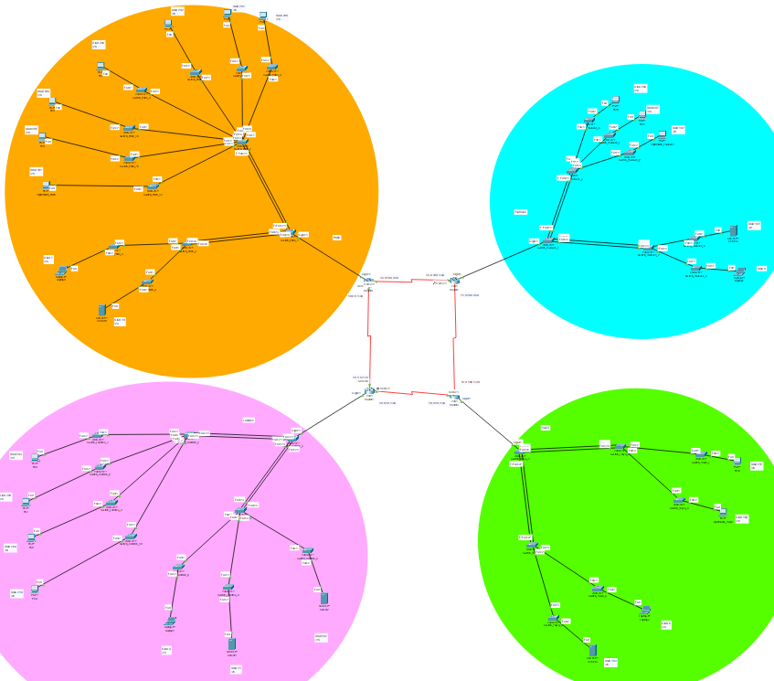

Paris
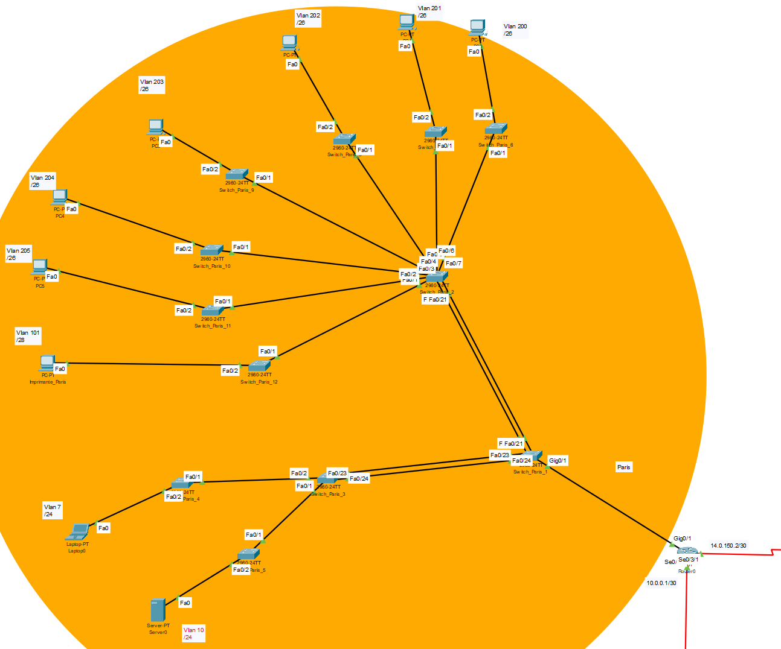
Londres
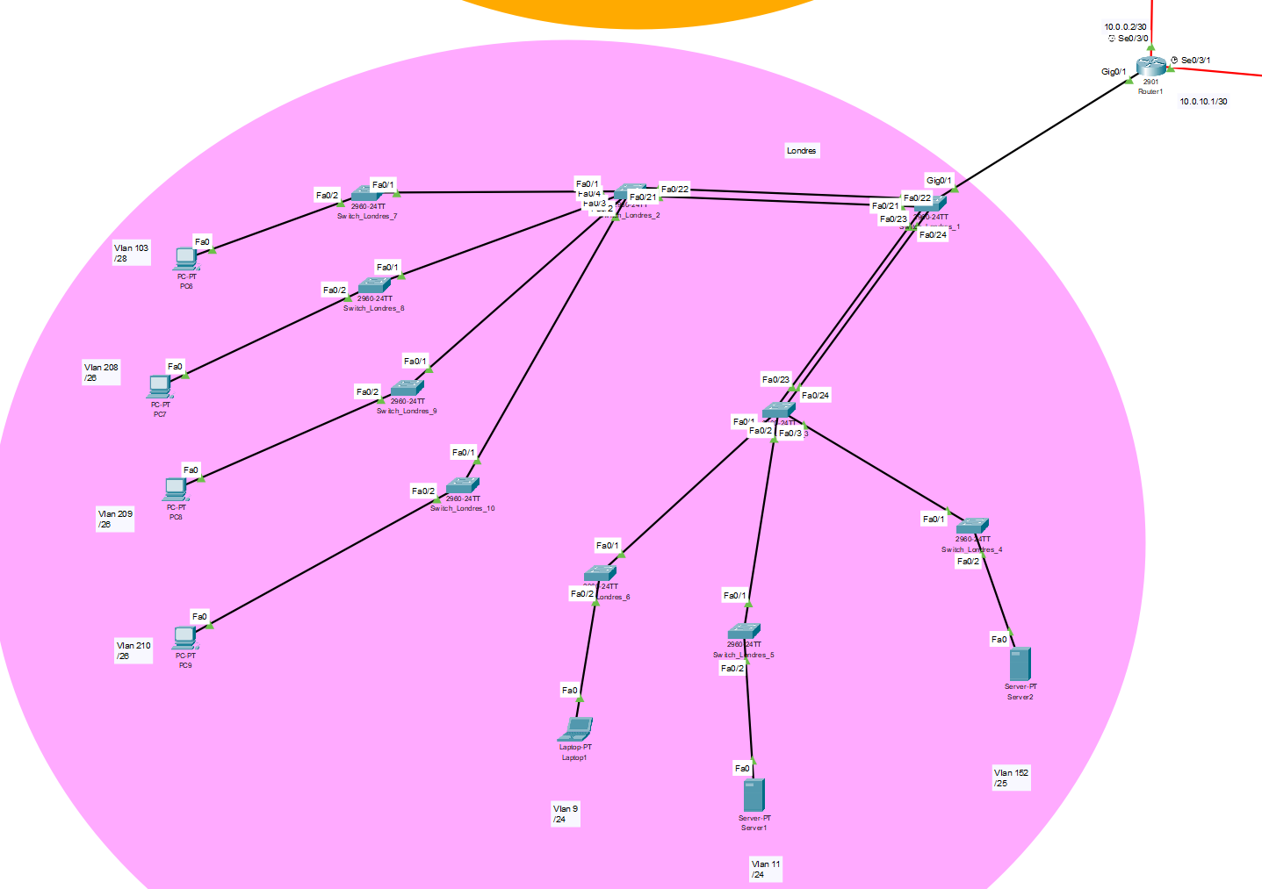

Tokyo
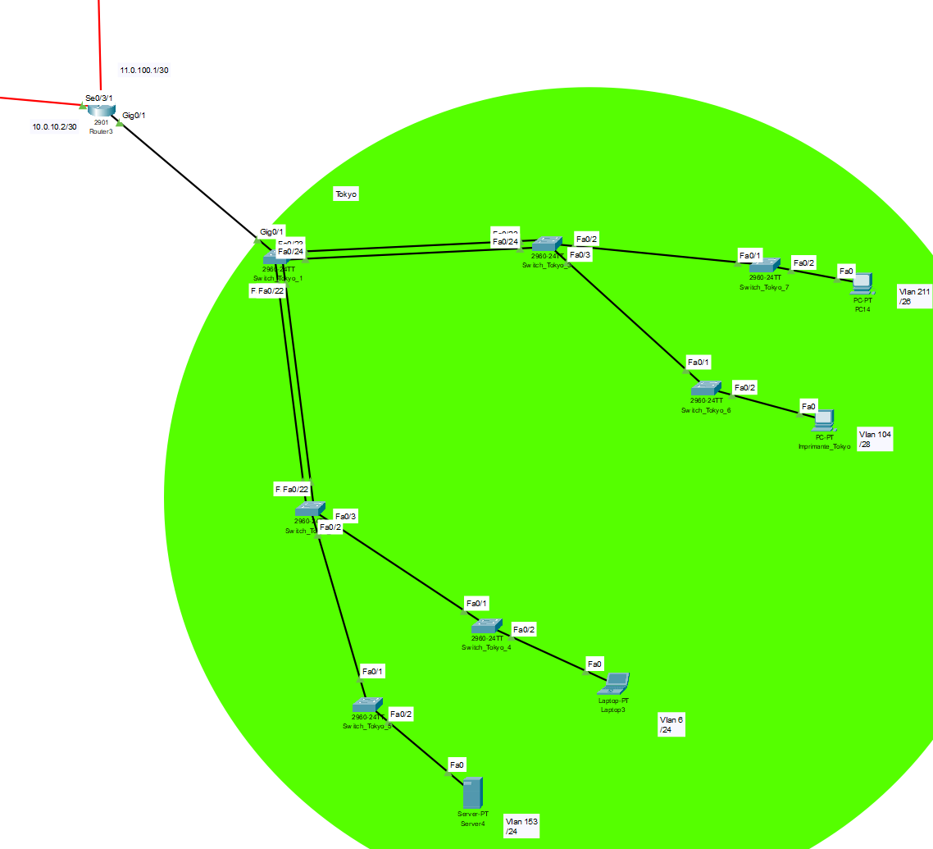
Toulouse
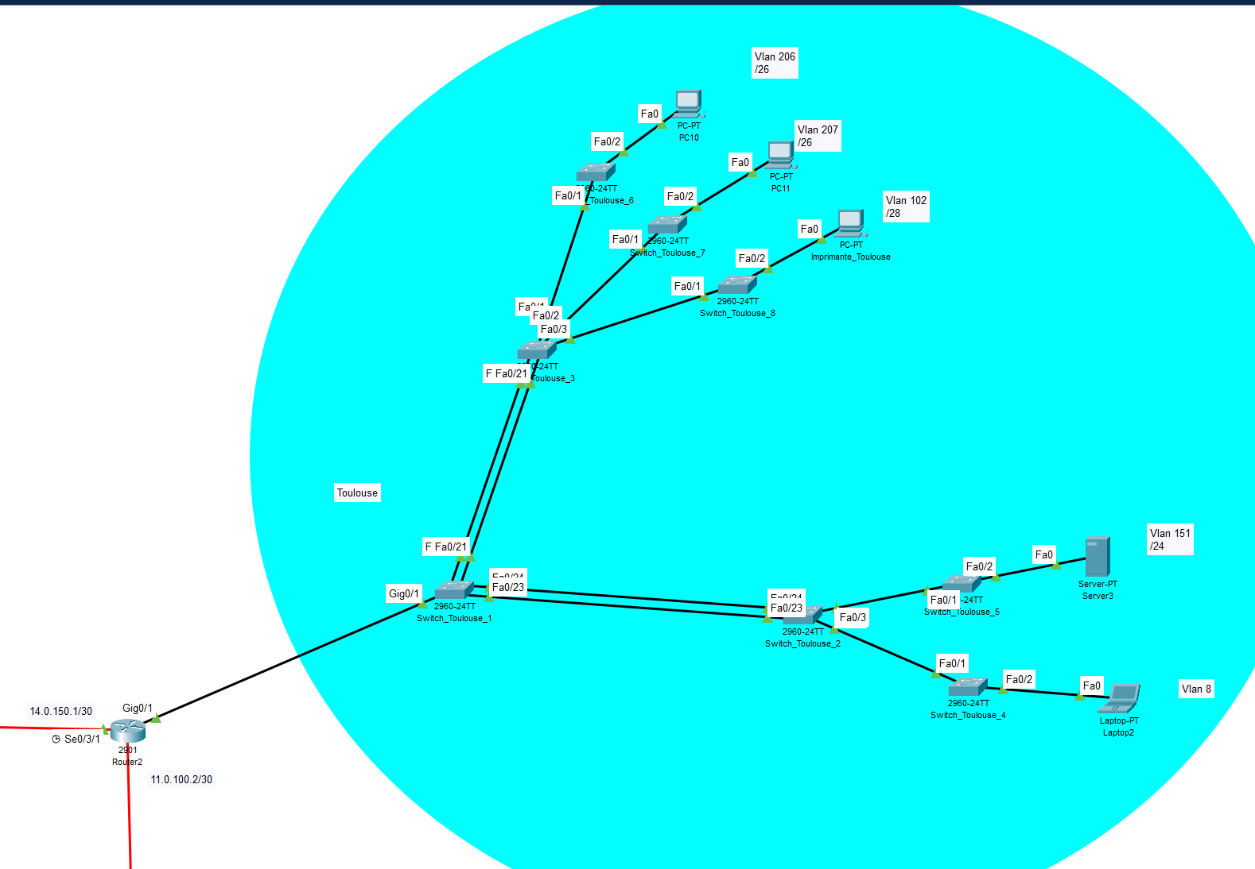
Capture d’écran pings PC Admin Paris vers les autres sites
Pings des Vlan103 (Londres), Vlan 153 (Tokyo), Vlan 207 (Toulouse) depuis le Vlan7 qui est le Vlan administrateur de Paris
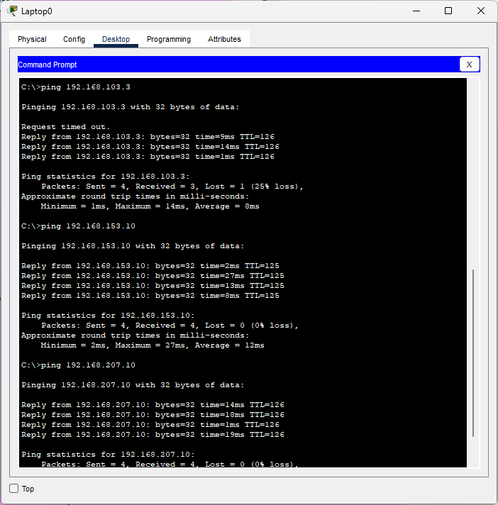

Traceroute
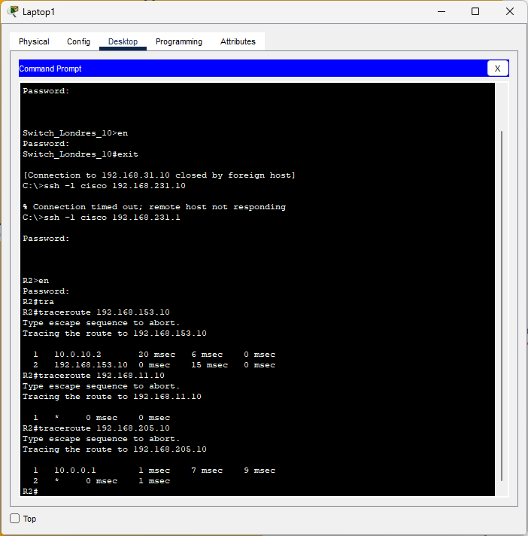
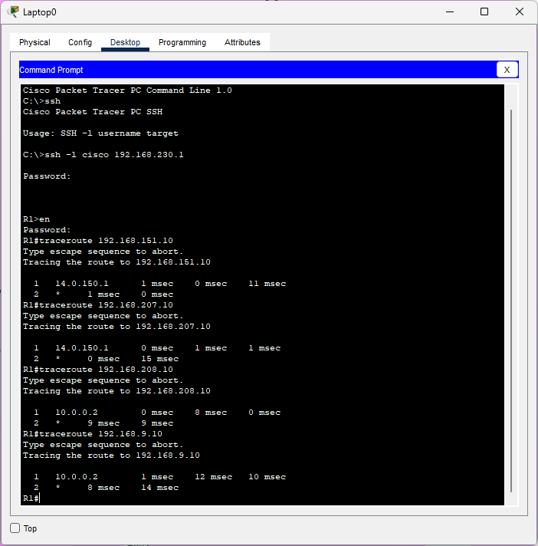

Connexion SSH sur différents équipements

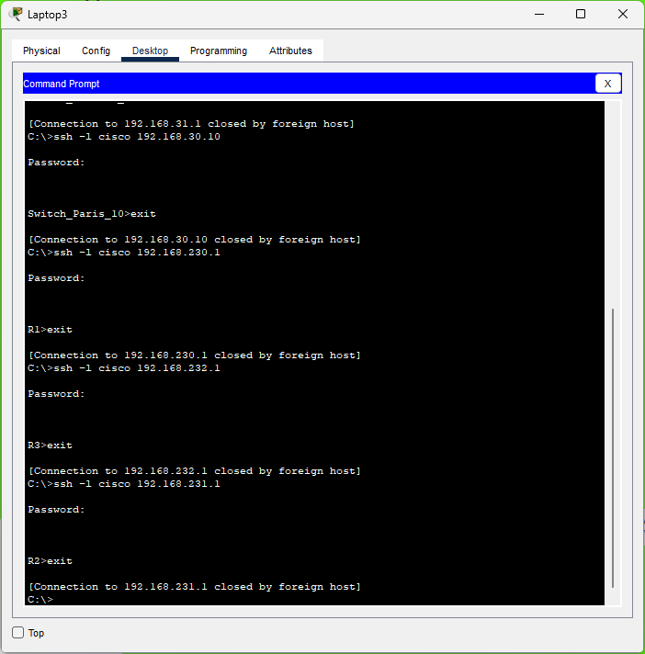
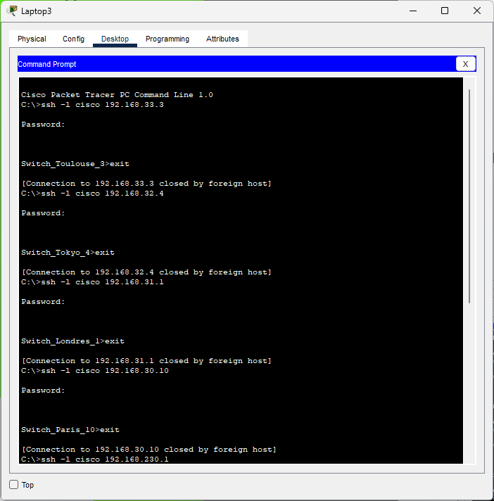

Configuration Router et Switch Coeur par site
Paris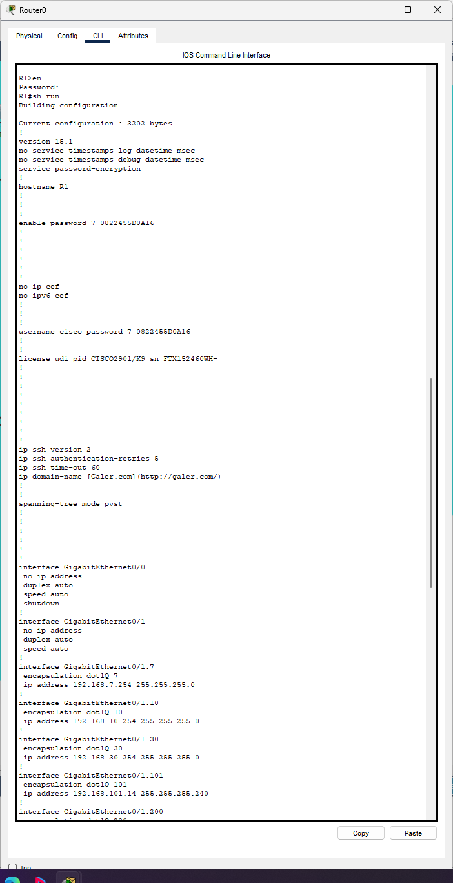
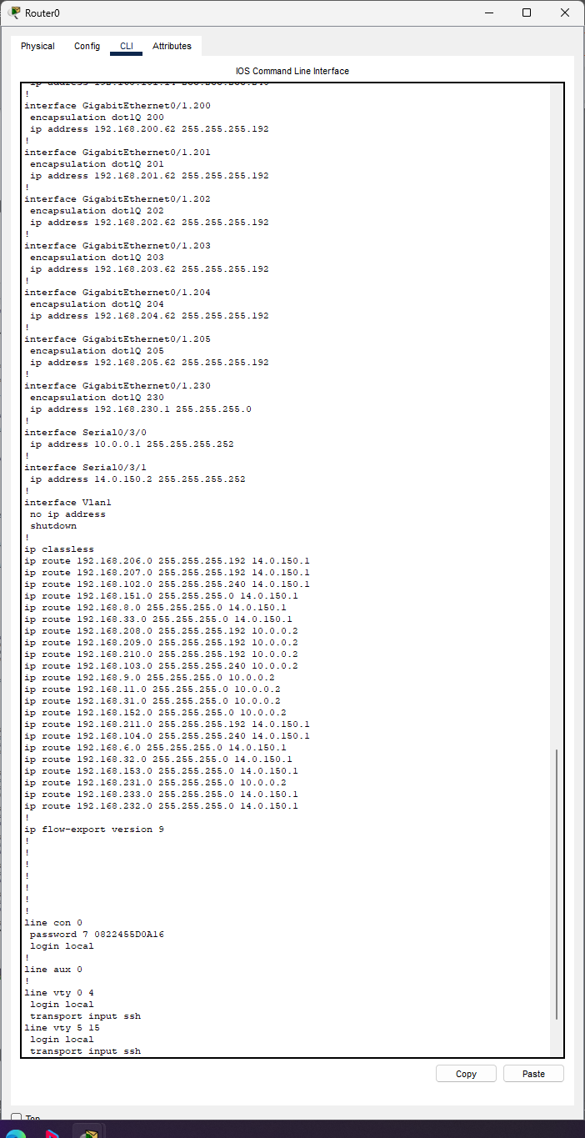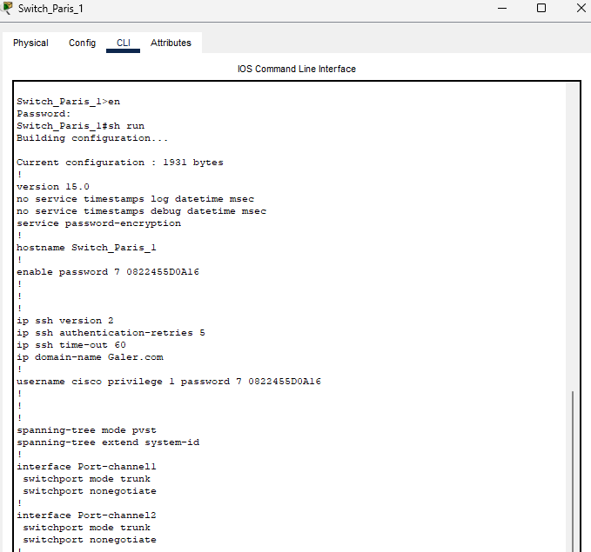
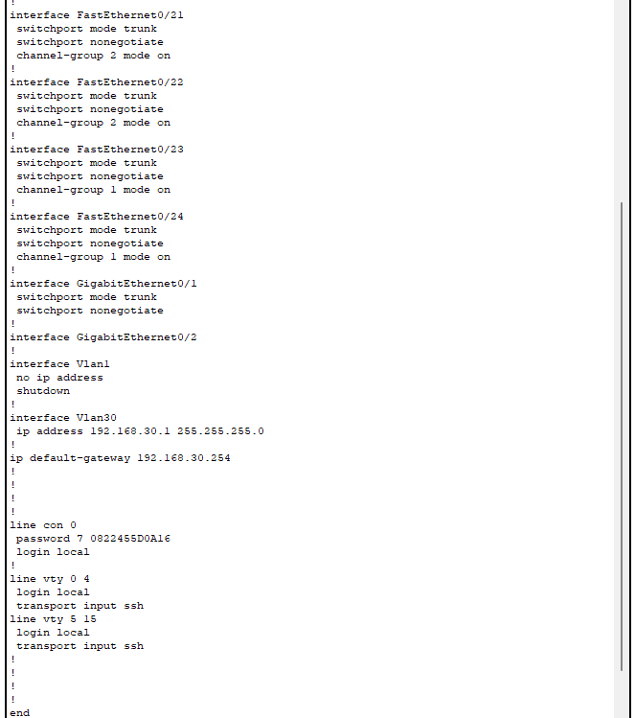

Londres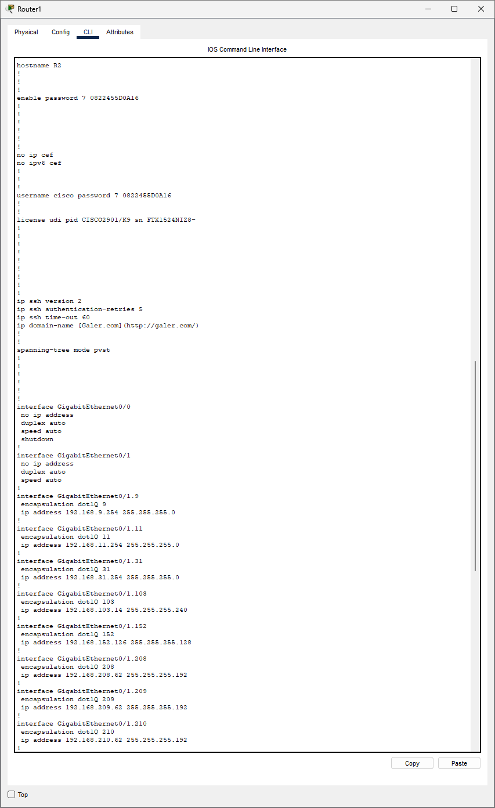
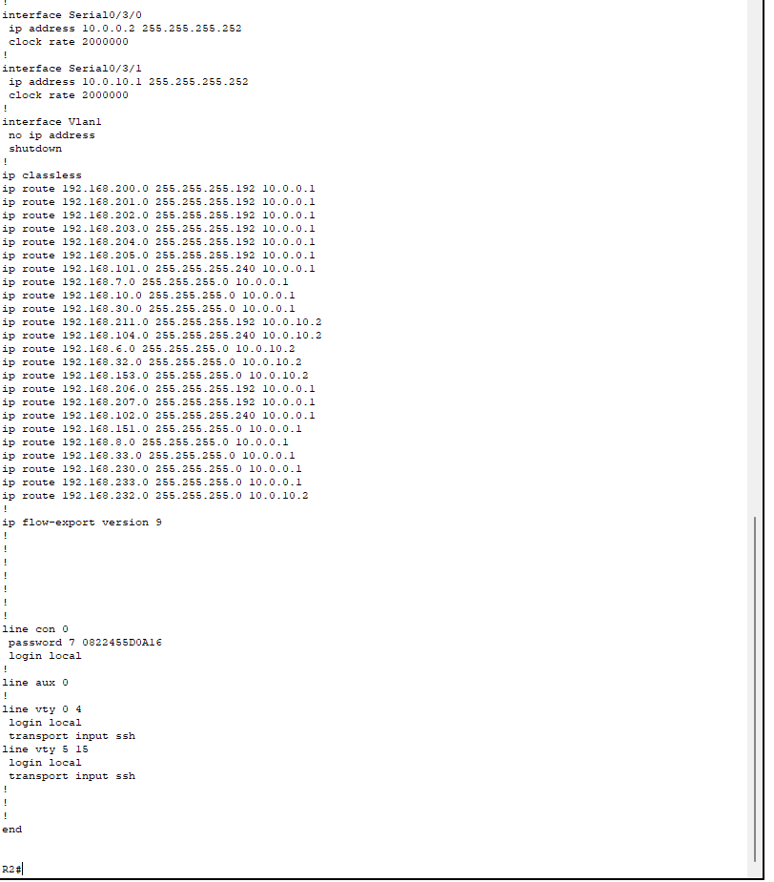
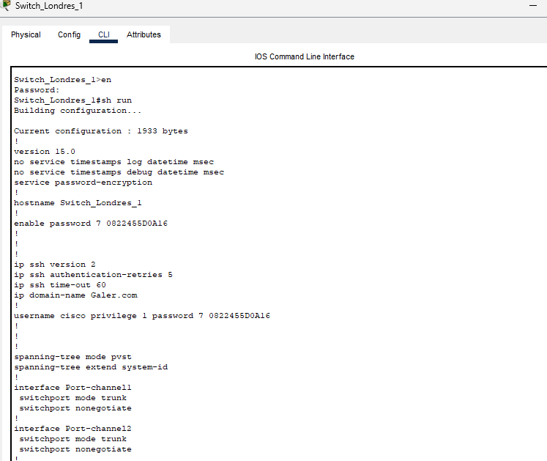
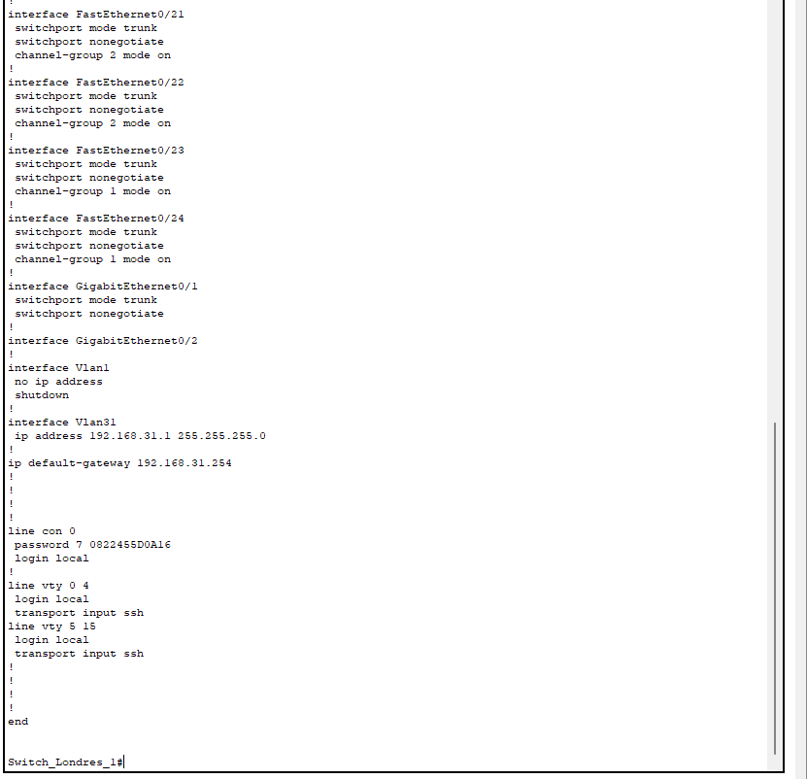

Tokyo
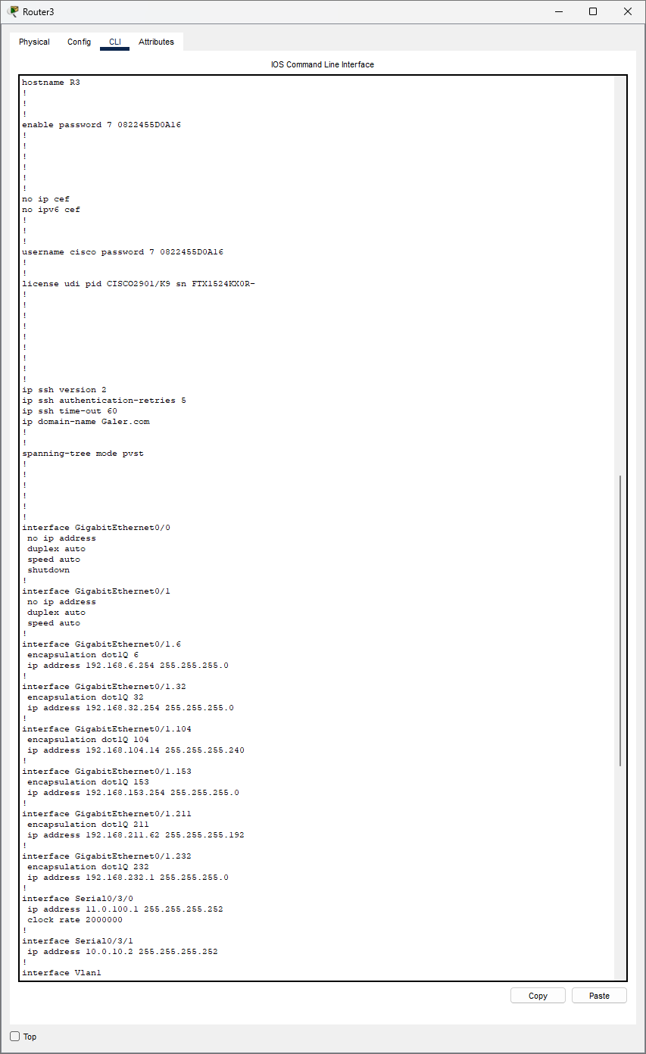

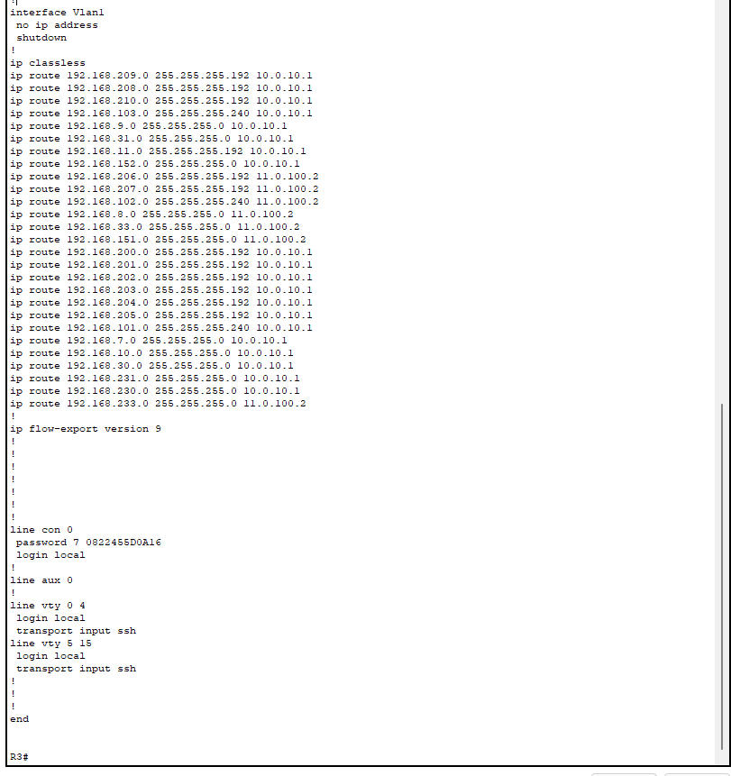

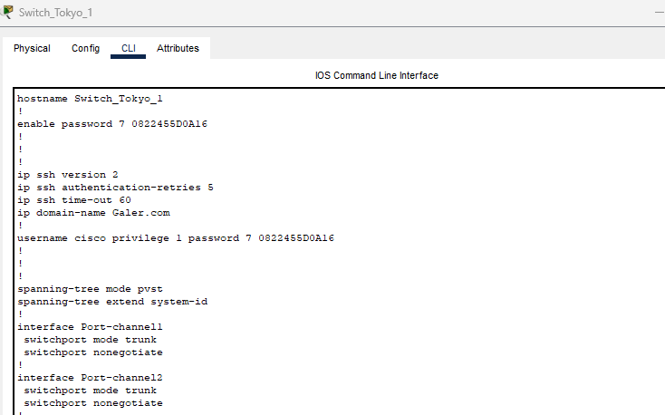
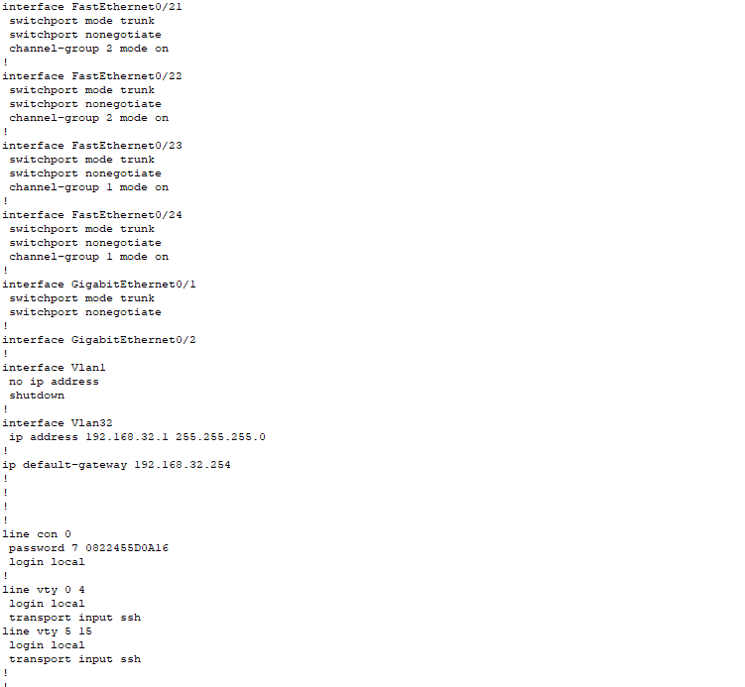
Toulouse
